My Target: ____ / 45 or ______ % Complete on the day of the test
(Circle when your test is handed back)

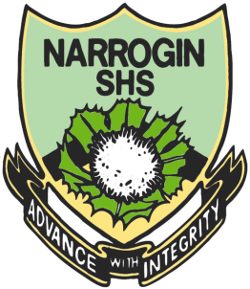
Name: __ Teacher:

Yr 7 Humanities and Social Sciences:

Aboriginal Language and Culture
Total marks  /54 | % | Weight  25%

Task 3 Semester 1: Create a Lantern
Aboriginal Vocabulary
Select a theme. Research Noongar Vocabulary related to the theme. Source pictures related to the theme. Display in a lantern format to inform an audience.
Select a theme either:
- Related to Aboriginal culture or (2) An Aboriginal person of note.
You must: Design a lantern for the purpose of display.
Select Noongar vocabulary related to your theme.
Select pictures representing your theme.
Marking key:.
 | 1 | 2 | 3 | 4 | 5 | 6 | 7 | 8 | 9 | 10
Booklet:
Planning page (staple behind this sheet)
Brainstorm
Reference research
Reference each picture
PMI chart
Lantern for display:
Clear theme
Title of theme attached
Ten Noongar words about your theme with translations into English
Ten pictures

What is your theme? _____________________________________________________

Brainstorm your ideas for a theme.

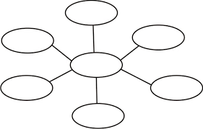
List of resources used
The ethical recording and communicating of evidence: List the bibliography information of all resources from which you have taken information. You are legally required to acknowledge the author or editor who wrote or compiled the information you have used for your assignment.
Bibliography/reference list framework
Books
Author | Year | Title | Publisher | Place
More than one author

Encyclopaedia or dictionary
Author | Year | Title of article | Title of encyclopaedia | Volume | Publisher | Place | Page(s)

Magazine articles
Author | Year | Title of article | Title of magazine | Volume | Number | Page(s)

World wide web – document
Author | Year or last update | Title of website | Date retrieved | ULR (website address)

World wide web – image
Title | Format | Year | Date retrieved | ULR (website address)

Online encyclopaedia
Title of article | Year | Title of website | Date retrieved | ULR (website)

